Miles Per Gallon – README

The objective of the application is to provide the user with the mean(city miles per gallon) and the mean(hwy miles per gallon) based on the cylinder input (4, 6, 8). The data used for the calculations was ggplot2 mpg dataset (described here: <https://rpubs.com/shailesh/mpg-exploration>).

The libraries required should you want to download the code are:

# Libraries

library(shiny)

library(datasets)

library(UsingR)

library(ggplot2)

Here are screen shots of the application:

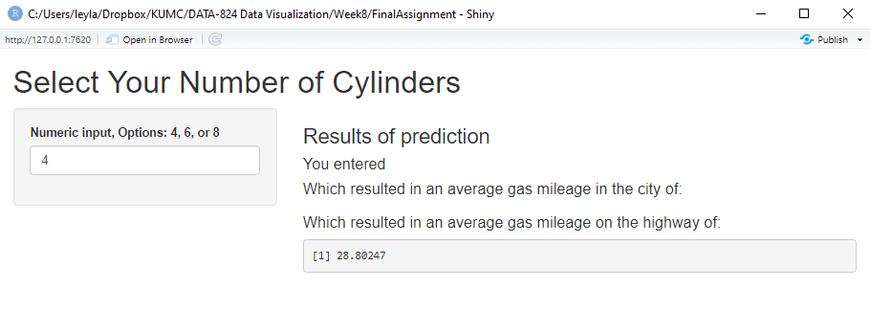

The application starts at 4 and increments 2 and max is 8 so the user only can add 4, 6, 8. If the user selects anything different, this message is shown.

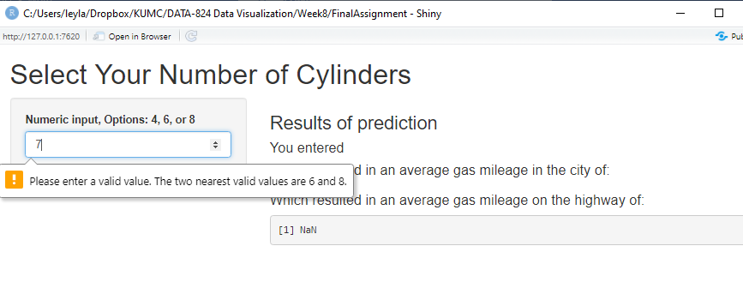

While the intention is for the user to get both city and highway mileage depending on the input, I could only get one output to return: EITHER city or highway. Many hours were spent trying to get this shiny app to be just as I envisioned in my head, but I got stuck showing both city and highway mileage.